This simple program demonstrates some of the functionality of this StringSet class.

Below is the output of the main function.

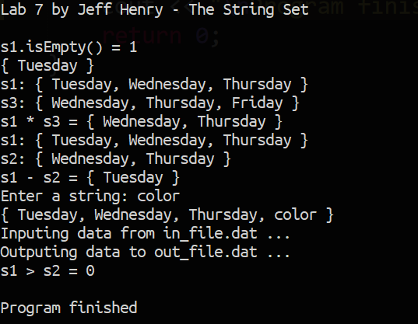

This is the in_file.dat.

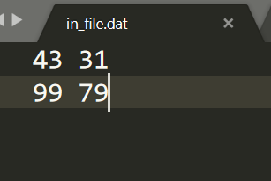

This is the out_file.dat.

